**Modern Wavy Wooden Wall Shelf**

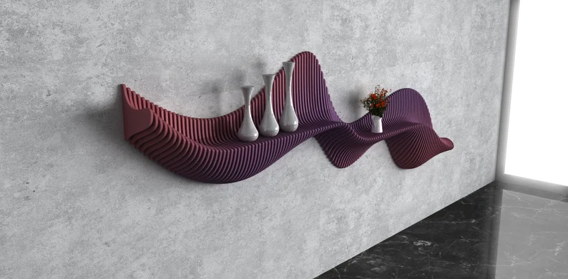 A Modern Wavy Wooden Wall Shelf is a stylish and unique storage solution that blends contemporary design with artistic flair. Featuring fluid, curved edges that create a wavy appearance, this shelf adds a dynamic and sculptural element to your space. Crafted from high-quality wood, it showcases the natural beauty of the wood grain while offering practical storage for books, plants, or decorative items. The wavy design makes it a statement piece, perfect for modern, minimalist, or artistic interiors. Whether placed in the living room, bedroom, or office, the Modern Wavy Wooden Wall Shelf brings both functionality and creativity to any wall.